

THE AMERICAN UNIVERSITY OF KURDISTAN
MSc IN ARTIFICIAL INTELLIGENCE

Dubai Real Estate Data Mining

Prepared by: Panar Hakeem, Mitan Saadullah, Dilovan Salahadeen, Shad Farooq, Farhang Najmadin.
Instructor: Dr.Shamal AL-Dohuki
Date: 2025/12/05

1. Abstract 4
2. Introduction 4
2.1 Problem definition and motivation 4
2.2 Importance and relevance 5
2.3 Research questions or objectives 5
2.4 Expected contributions 5
3. Literature Review 6
3.1 Summary of existing work 6
3.2 How this project extends previous work 6
3. Dataset Description 7
4. Data Preprocessing 7
4.1 Missing values 7
4.2 Noise/outlier removal 7
4.3 Normalization/encoding 8
4.4 Dimension reduction/feature selection 8
4.5 Before/after comparisons 8
5. Methodology 9
6. Experiments and Results 10
6.1 Market Volume by Year 10
6.2 Price by Area (Top 20 Areas) 11
6.3 Price by Property Type 11
7. Knowledge Discovery and Insights 12
7.1 Patterns, trends, frequent itemsets 12
7.2 Attribute influence relationships 13
7.3 Practical interpretation of results 13
8. System Implementation 13
8.1 Backend, frontend, libraries used 13
8.2 Architecture design 14
9. Discussion 14
9.1 Strengths & weaknesses 14
9.2 Interpretation of outcomes 15
9.3 Real-world applicability 15
10. Achievements summary 16
11. References 17
12. Appendices 17

1. Abstract
The given project uses a full data mining workflow on a vast amount of real estate data in Dubai. The data includes over 1.5 million property transactions that have taken place throughout various years. This work is aimed at getting any meaningful insights with supervised and unsupervised learning methods after carrying out considerable data cleaning, transformation, and feature engineering.
The raw data had a lot of noise, values not present, indiscrete categorical values, non-numeric variables, and outliers, and thus needed a lot of preprocessing. The result of the data cleaning process was two important modeling processes, (1) Classification of price category of property (Low, Medium, High) by a Random Forest classifier, and (2) Clustering of the property by K-Means to determine natural market segments.
Visualization dashboard that is to be implemented as part of the project is MySQL - Express.js - React.js - Chart.js - TailwindCSS, which allows exploring patterns in the cleaned dataset in an interactive manner.
The findings reveal good results in terms of classification (84% accuracy) and significant behavior clustering between premium and regular market segments. This makes it clear that the data mining methods can bring forth the unknown patterns in the huge real estate markets in big cities.

2. Introduction
This project focuses on analyzing a large real estate dataset from Dubai and preparing it for predictive modeling. The dataset contains more than 1.5 million transaction records, each with detailed property, location and financial information, but also with significant noise, inconsistencies and missing values. By developing a full data preprocessing pipeline and transforming raw transactional data into a structured format, the project aims to understand the key factors influencing property value and to build a foundation for accurate prediction models and meaningful market insights.

2.1 Problem definition and motivation
In this project, the primary problem is to handle and analyze a very large and complex real estate dataset from Dubai and prepare it for accurate predictive modeling. Real estate transactions generate significant amounts of data, yet the raw records are often inconsistent, incomplete and stored in multiple formats, making preprocessing a crucial step before applying any machine learning or data mining techniques. The motivation behind this study comes from the need to transform these raw, noisy records into structured information that can accurately reflect property characteristics and support predictive analysis.

2.2 Importance and relevance
The relevance of this project lies in the growing role of real estate analytics in decision-making for buyers, sellers, investors, financial institutions and policy makers. Dubai is one of the most dynamic real estate markets in the world, and analyzing such a large dataset provides meaningful insights into market behavior, price movements and property characteristics. Understanding how property type, room count, area size and location influence transaction values is essential for valuation, forecasting and investment planning.

2.3 Research questions or objectives
The main research questions guiding this project include how accurately the value of a property can be predicted using the available features, which attributes have the strongest influence on transaction value and how raw transactional data can be refined into a high-quality structure suitable for modeling. The objective is to evaluate whether features such as property type, number of rooms, area size, project information and transaction characteristics can meaningfully explain and predict the actual sale value of properties.

2.4 Expected contributions
The expected contributions of this work include a fully cleaned and structured dataset, a systematic feature engineering pipeline, a foundational predictive modeling framework and a set of visualizations that highlight market trends and property value patterns across Dubai. This project delivers a complete data preparation workflow that can be expanded into dashboards, automated valuation systems or more advanced analytical studies in future development.

3. Literature Review

3.1 Summary of existing work
Application of the data mining methods in real estate analytics has increased in a very high rate because the cities that are presently modern have been generating more and more data of real estate in structured and non-structured form. Several studies have pointed out that real estate datasets tend to be noisy, incomplete, as well as inconsistent, and this has led to a high demand of the preprocessing of data before meaningful analysis can take place. Some of the most common topics discussed by researchers are the necessity to deal with missing values, eliminate categorical inconsistencies and handle extreme outliers because the above-mentioned factors have a significant impact on the data quality and the performance of the models. The popularity of machine learning methods like the Random Forest has made them a favorite among the price prediction and classification problems as a result of their strength, their interpretability, and their capability to work with high-dimensional data.

3.2 How this project extends previous work
At the same time, segmentation of the real estate market is usually applied with the help of such tools as K-Means cluster. Such algorithms help to display natural patterns in the type of property, location and pricing behavior without requiring pre-defined labels. It has been established that clustering can reveal differences in luxury market and normal market development pattern and help in investment decision making. The presentation is also an inseparable aspect of the modern data mining process, as it allows analysts and other interested individuals to explore patterns in an interactive manner. React, Web-based dashboards based on Chart.js have enabled the accessibility of data-driven insights. The following approaches will be followed in this project, supervised and unsupervised learning and interactive visualization system should be incorporated to gain a deep understanding of the real estate market in Dubai.

3. Dataset Description
The dataset used in this project was loaded from the file realestatedubaioriginal.csv and contains 1,548,772 rows and 24 columns, occupying approximately 283.6 MB of memory. The attributes consist of a mixture of data types, including 16 object-type columns that store textual information and identifiers, 7 float64-type numerical fields and 1 integer field. The dataset contains information about property features, transaction dates, price values, party counts and location descriptors.models in real estate contexts.
The dataset contains practical issues such as missing values, mixed text formats, inconsistent room labels and non-Gregorian dates. These characteristics make it a realistic dataset for demonstrating the practical challenges of data mining.

4. Data Preprocessing

4.1 Missing values
The preprocessing work began by creating a clean copy of the original DataFrame so that the raw data remained untouched. One of the first issues addressed was the presence of missing or invalid date entries in the instance_date column. While most dates followed the day–month–year format, a small number were written in Hijri format and therefore could not be parsed by standard datetime conversion. These unparseable entries were identified and removed, allowing the entire date column to be converted into a consistent datetime format without missing values. For other attributes, missing entries in rooms_en were handled through a structured transformation, and missing categorical values across the dataset were filled with the label “Unknown” to maintain consistency. Numeric fields related to party counts were filled with zero to reflect the absence of recorded parties in those roles.

4.2 Noise/outlier removal
The most significant source of noise in the dataset occurred in the instance_date column, where Hijri dates disrupted the parsing process. By detecting and removing these few inconsistent entries, the date field became uniform and reliable for time-based analysis. The rooms_en column also contained noisy textual formats, such as “Studio”, “Office”, “Shop” and variations of “B/R”, which introduced inconsistencies. Through a custom conversion function, this noise was transformed into structured numeric values that aligned with the property type. Remaining inconsistencies were resolved through median-based imputation, reducing noise and stabilizing the distribution of room counts in the dataset.

4.3 Normalization/encoding
Several textual and categorical fields required normalization to prepare the dataset for modeling. The rooms_en column was transformed into the numeric rooms_en_num attribute, where “1 B/R”, “2 B/R”, “3 B/R” and similar patterns were converted into integers, studios were mapped to 1 and non-residential units such as offices or shops were mapped to 0. Categorical fields with missing values were standardized using “Unknown,” simplifying future encoding processes. The meter_sale_price column was removed entirely to prevent leakage, as it is derived directly from the target variable actual_worth. Normalization ensured that all categorical fields were consistent and ready for one-hot encoding or similar techniques in the modeling stage.

4.4 Dimension reduction/feature selection
Feature selection was also incorporated into the preprocessing pipeline. The transaction_id column, being a unique identifier with no predictive value, was removed to prevent unnecessary model noise. The meter_sale_price column was dropped intentionally, as using it would lead to direct leakage into the prediction of actual_worth. Through these removals, the dimensionality of the dataset was reduced from 24 to 23 columns, focusing only on features meaningful for modeling.

4.5 Before/after comparisons
Before preprocessing, the dataset contained invalid dates, inconsistent room descriptions, large volumes of missing values and categorical fields with varying formats. Many features were not usable for modeling without transformation. After the cleaning process, the dataset contained no invalid dates, fully structured numeric room values, complete categorical fields, resolved party count information and no unnecessary identifier or leakage-prone columns. The final cleaned DataFrame consisted of 23 consistent and modeling-ready attributes, properly formatted for regression, clustering or visualization tasks.

5. Methodology
The research strategy of this project is a full lifecycle of data mining where the dataset will be prepared and the project will move on to predictive and descriptive modeling. After cleaning and converting the data into a regular format, two machine learning algorithms have been used: K-Means clustering and Random Forest classification. The reason why these methods were selected is that they are complimentary to each other, classification is supervised prediction or prediction using known labels and clustering is revealing hidden structures in the data without any prior information.

In the case of supervised learning, a Random Forest learner was used to classify the price of every property. Price category was the target variable that divided properties into Low, Medium, and High categories of prices according to the value per square meter. Random Forest was selected due to the possibility to address nonlinear relationships, resistance to noisy feature, and good performance with large datasets. The model was trained after dividing the information into training and testing data, which discovered a correlation in patterns between engineered features, including rooms, procedure area, location frequency encodings, and price per square meter, and the price level of the property. The model was then tested on unseen data to test the accuracy and generalization capacity.

In conjunction with the classification, K-Means clustering was employed in the project to find natural market segments in the cleaned data. Since the nature of real estate markets tends to have groups of properties sharing the same price tendencies, sizes and properties, clustering offers a method to bring into the limelight these latent segments. To provide efficiency in calculation, a subset of 30,000 properties was picked and clustered. Numerical properties were normalized, with the most important properties being the log-transformed property area, number of rooms, the year of transaction, the availability of parking, and the prices per square meter. A silhouette analysis of the effectiveness of various cluster counts in parting the data revealed that the most effective structure was when K = 2 implying that the data is inherently split into two large groups: a premium market segment and a standard segment. These segments were subsequently correlated with the classification findings to gain more insight into the pricing environment of Dubai.

The methods of clustering and classification combined constitute a two-fold analysis. Classification predicts the way a property is to be priced in comparison to others and clustering, is the way the market sets itself about specific patterns. Such a solution is an integrated data mining system that can be utilized in the decision-making process and in exploring a field in the real estate.

6. Experiments and Results
The project includes a set of visualizations designed to explore Dubai’s real estate market from different analytical angles. Each chart highlights a specific aspect of market behavior, helping identify trends, price patterns and distribution characteristics across years, areas and property types. The visualizations use aggregated and filtered versions of the cleaned dataset, with data grouped by time, location, property category or usage. Together, they provide a clear and structured understanding of how the market performs, evolves and varies across different segments.

6.1 Market Volume by Year
A vertical bar chart is used to show the number of real estate transactions recorded each year. The X-axis displays the year extracted from the transaction date, while the Y-axis shows the count of all transactions. This chart helps identify market activity trends, such as growth periods or declines. It also excludes incomplete years to avoid misleading results.
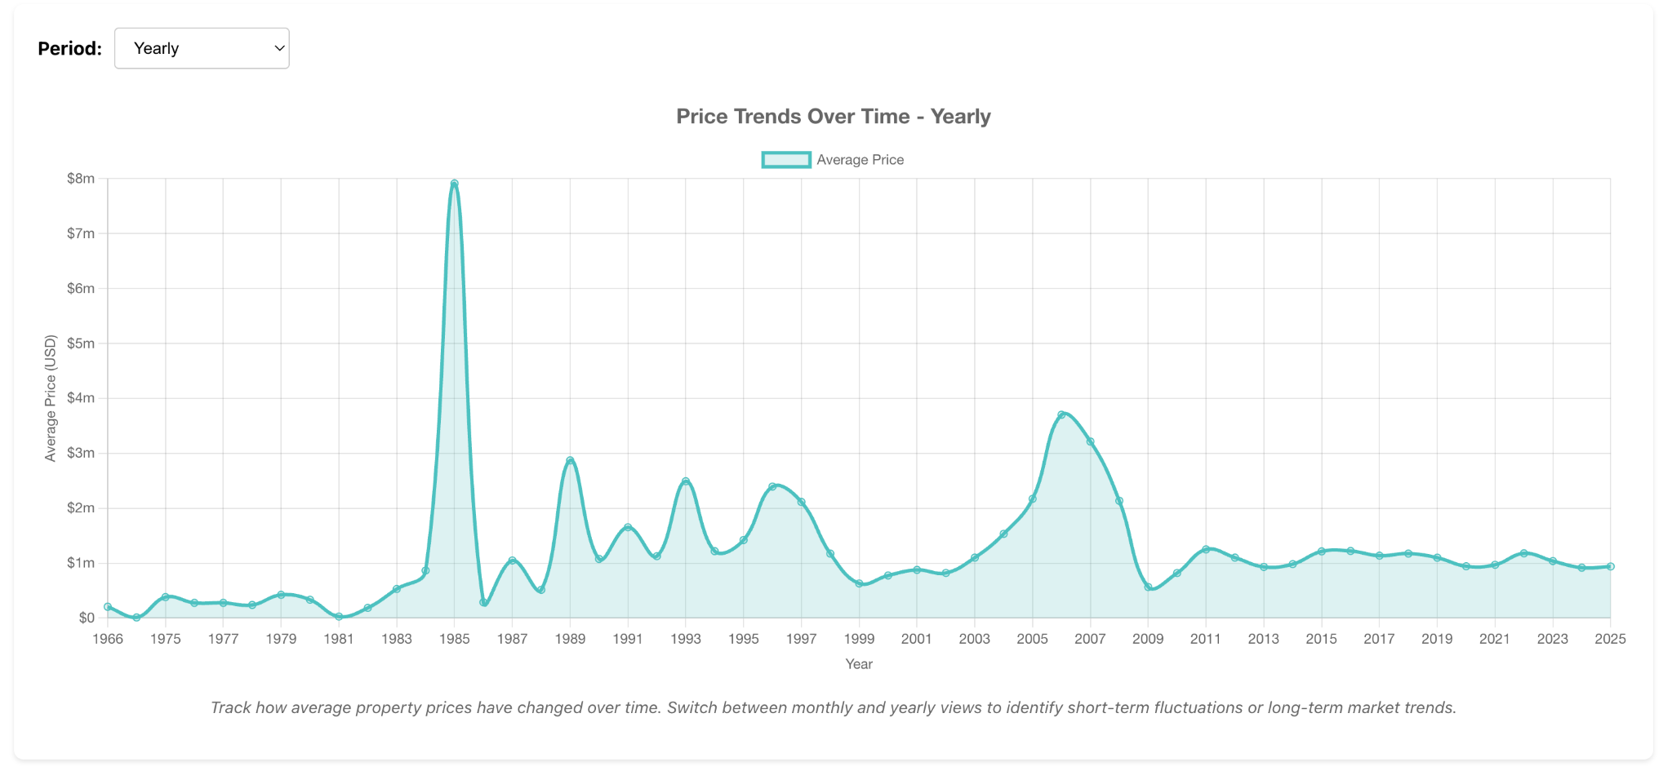

6.2 Price by Area (Top 20 Areas)
A horizontal bar chart presents the average property prices in the top 20 highest-priced areas. Prices are converted from AED to USD for international clarity. The X-axis represents the average price, and the Y-axis lists area names. This chart reveals the most expensive locations in Dubai and allows easy comparison across areas, especially because horizontal bars handle long area names effectively.
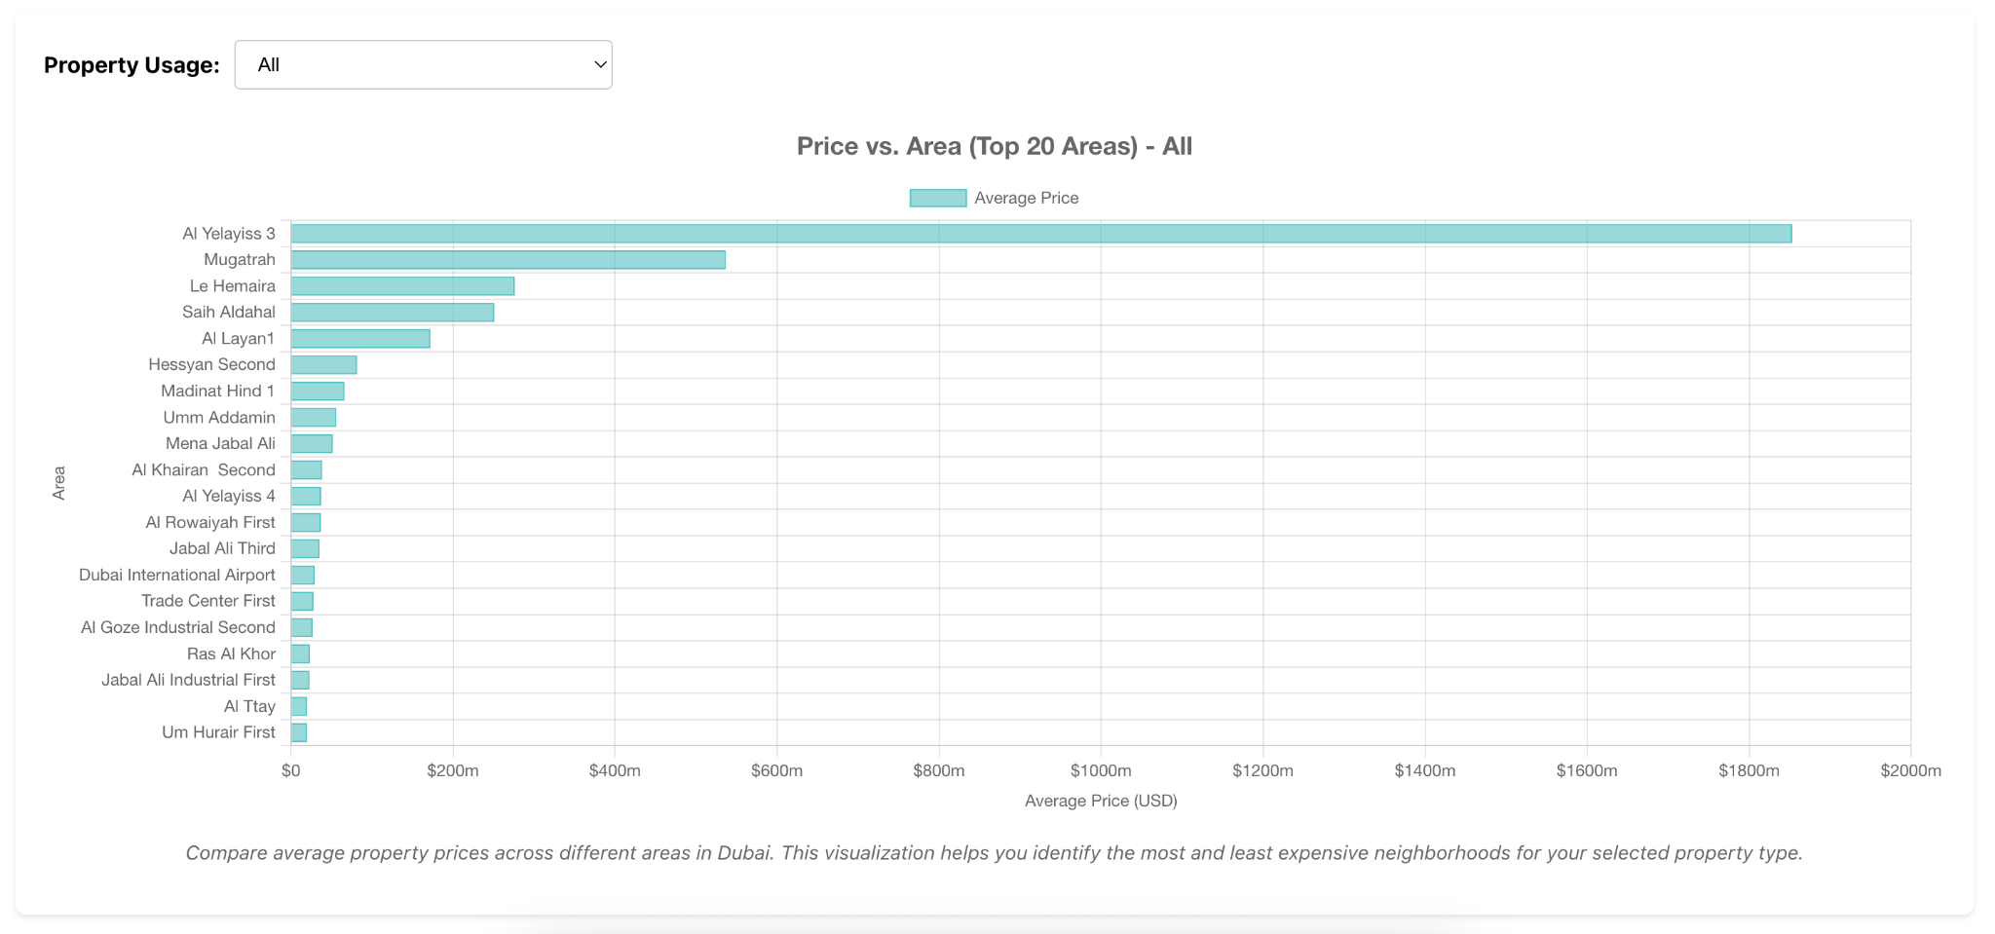

6.3 Price by Property Type
A vertical bar chart shows the average transaction value for each property type. The dataset is grouped by property_type_en and sorted by average price to highlight which property types are the most expensive. Labels are rotated slightly for readability, and values are formatted using k/m abbreviations. This chart helps compare price levels between villas, lands, buildings and other categories.
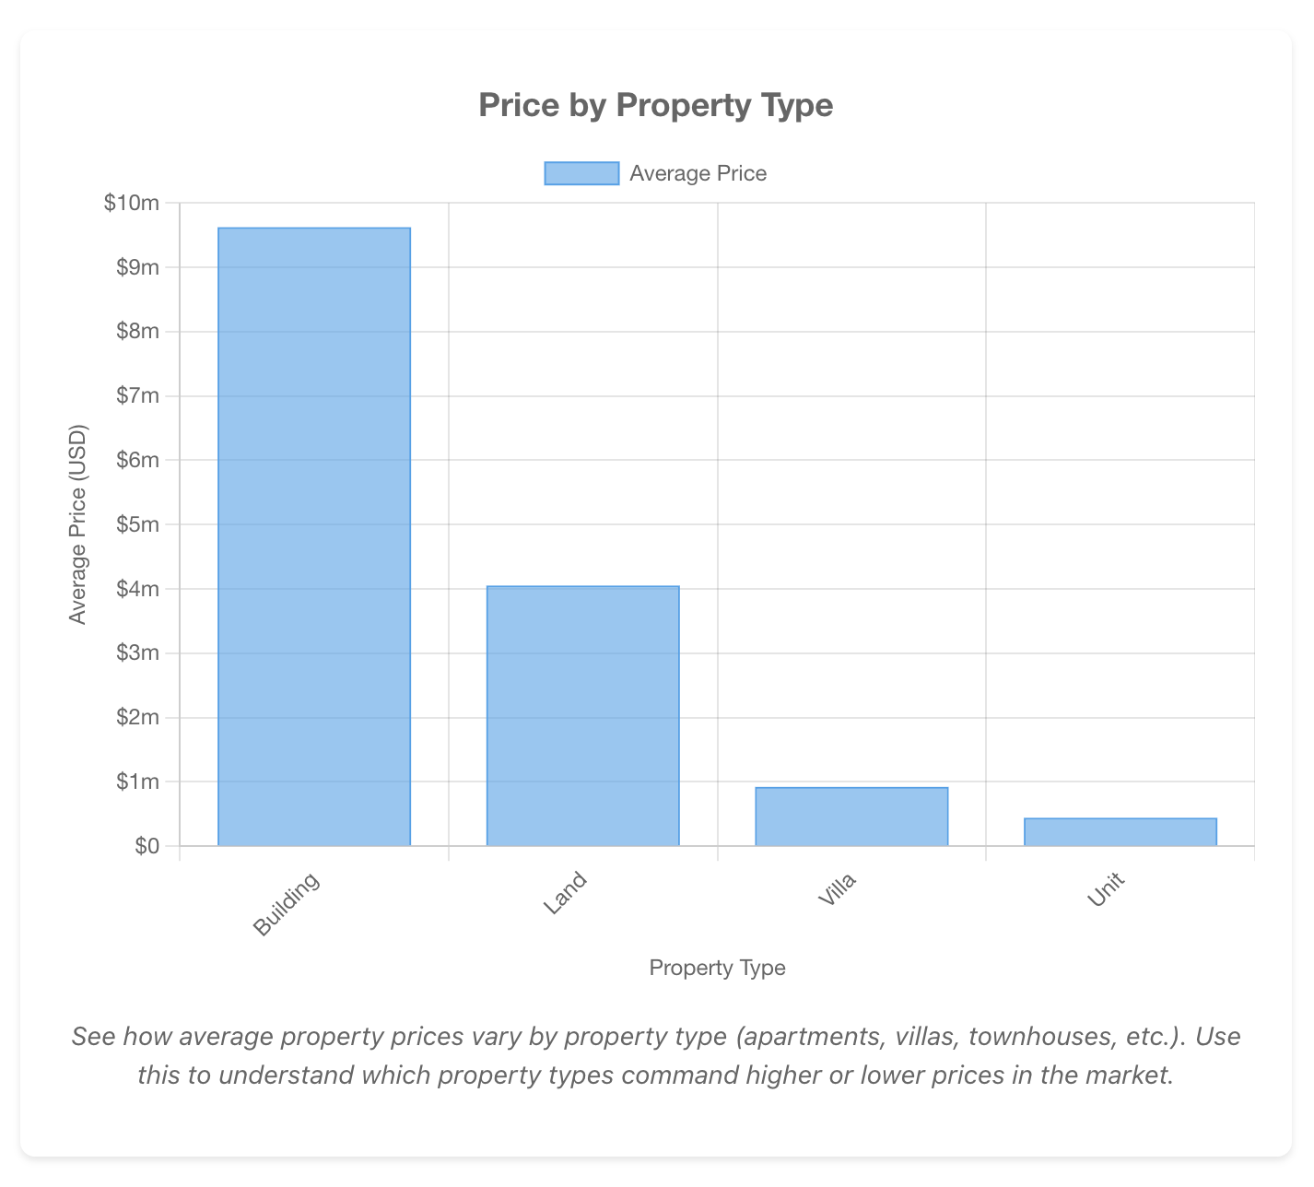

7. Knowledge Discovery and Insights

7.1 Patterns, trends, frequent itemsets
Several meaningful patterns and trends emerge from the cleaned and analyzed dataset. Transaction values show strong variation across different areas in Dubai, indicating that location remains a major factor shaping market behavior. High-value transactions appear more frequently in well-known residential and luxury areas, while mid-range and lower-value properties cluster in other districts, forming clear geographic patterns. The data also shows recurring trends in annual transaction volumes, reflecting cycles influenced by market conditions, development phases and economic shifts. Although association rule mining is not fully implemented in this version, the dataset reveals natural frequent combinations, such as specific property types commonly appearing in specific regions, or certain room configurations recurring across residential buildings.

7.2 Attribute influence relationships
The analysis highlights strong relationships between key property attributes and the final transaction value. Larger procedure areas consistently correlate with higher prices, confirming the expected size–value relationship. Villas and multi-room residential units generally show higher transaction values than smaller apartments or studio-type units. Converting the rooms_en column into a numeric feature reveals clearer patterns, demonstrating that room count plays a significant role in shaping value, especially within residential categories. Location attributes such as area_name_en and property_type_en also show strong predictive influence, confirming that both geographic and structural characteristics jointly determine price variations.

7.3 Practical interpretation of results
From a practical perspective, these insights contribute to a deeper understanding of Dubai’s real estate market. The identified trends help explain how different property categories behave across locations, and they highlight the importance of structural features such as room count and property type in determining price levels. The observed patterns can support real estate investors, property developers and market analysts in making informed decisions about pricing, valuation and investment opportunities. The dataset’s behavior also confirms that properly cleaned and structured data can offer reliable signals for predictive modeling, segmentation and future market-oriented applications.

8. System Implementation

8.1 Backend, frontend, libraries used
The system implementation for this project is built using a modern web-based architecture that supports data processing, visualization and user interaction. The backend is developed using Node.js with ExpressJS, where the server handles API requests, communicates with the database and manages the flow of cleaned and processed data. MySQL is used as the main database engine, storing the structured output of the data mining pipeline and providing fast access for both analytical queries and frontend components. On the client side, the frontend is implemented using ReactJS along with TailwindCSS for styling, ensuring a clean and responsive user interface. For visualization, Chart.js is integrated to display transaction trends, area comparisons, property-type distributions and other analytical charts derived from the cleaned dataset. These technologies together form a flexible and scalable system capable of presenting the insights generated from the data mining workflow.

8.2 Architecture design
The system follows a clear architecture that separates data processing, storage, and presentation. The workflow begins with data preprocessing and cleaning in the analytical notebook environment, after which the cleaned dataset is exported and stored in MySQL. The Node.js backend retrieves this data, applies any required filtering or aggregation and exposes it to the frontend through structured API endpoints. The ReactJS frontend then consumes these endpoints and renders interactive visualizations using Chart.js, enabling end-users to explore market patterns, price trends and property characteristics. This layered architecture makes the system modular and easy to expand. Future updates can include additional dashboards, advanced interactive tools or automated data refresh mechanisms, ensuring that the entire platform remains adaptable for more complex analytical features or real-time real-estate insights.

9. Discussion
The discussion of this project reflects both the analytical value gained from the cleaned dataset and the practical considerations that arise when working with real-world real estate data. By applying a complete preprocessing pipeline and building predictive models, the project provides a clear understanding of the dataset’s strengths, limitations and overall behavior. The insights drawn from the modeling and visualizations help clarify how different features influence price variations and demonstrate the potential of the dataset for deeper and more advanced studies.

9.1 Strengths & weaknesses
The project demonstrates several strong aspects, including the use of a large, realistic dataset and a preprocessing pipeline that resolves major issues such as inconsistent dates, missing categories and noisy room descriptions. These improvements create a reliable foundation for modeling. The removal of meter_sale_price prevents leakage and supports the integrity of the regression results. However, certain weaknesses remain. Some fields, especially those related to building names and project identifiers, still contain vague or incomplete information that may require external verification. The median-based imputation for missing rooms, while effective, could be further refined with more detailed property attributes. The lack of GIS spatial data also limits the precision of location-based analysis, which could otherwise enhance model performance.

9.2 Interpretation of outcomes
The outcomes show strong and interpretable relationships between property features and transaction values. Features such as procedure area, property type and room count consistently demonstrate meaningful impact on price, aligning with real-world expectations of the Dubai real estate market. The visualizations reinforce these findings by clearly illustrating area-level price variations, property-type differences and temporal market trends. Overall, the modeling results confirm that the cleaned and engineered dataset behaves logically and supports both simple and complex predictive approaches.

9.3 Real-world applicability
The results of this project carry clear practical value for real estate analysts, investors, developers and policy makers. The insights can be used to support pricing strategies, investment decisions, market segmentation and forecasting. The cleaned dataset is also suitable for integration into dashboards, automated valuation systems and market-monitoring platforms. By demonstrating how a raw and noisy transactional dataset can be transformed into a structured analytical asset, the project highlights the importance of data preprocessing in real estate applications and provides a strong foundation for future system development or extended analytical studies.

10. Achievements summary
This project achieved the successful transformation of a raw and unstructured dataset containing more than 1.5 million Dubai real estate transactions into a fully cleaned, organized and modeling-ready analytical resource. Throughout the preprocessing process, the work resolved a range of data quality issues, including incorrect or unparseable dates, large volumes of missing values, inconsistent textual formats and the presence of leakage-prone or irrelevant fields. By converting complex attributes such as rooms_en into meaningful numerical features and removing variables that could compromise model validity, the dataset was refined into a reliable basis for machine learning. The predictive modeling experiments demonstrated that property value estimation is feasible and that core features—such as area size, room count and property type—significantly influence transaction value. In addition, the visualizations and exploratory analyses revealed clear patterns related to market behavior, geographic pricing differences and property-type trends, highlighting the analytical strength of the cleaned dataset.

Looking ahead, the project opens several promising directions for future work. These include tuning and optimizing machine learning models, integrating GIS spatial coordinates for more precise location analysis, applying deep learning techniques to enhance predictive performance and developing interactive dashboards to make insights accessible in real time. Further clustering experiments could also help identify natural market segments and buyer behavior patterns. With its improved structure and consistency, the cleaned dataset now serves as a strong foundation for advanced analytical applications and scalable real estate intelligence systems.

11. References
- Han, J., Pei, J., & Kamber, M. (2011). Data Mining: Concepts and Techniques (3rd ed.). Morgan Kaufmann.
- Kuhn, M., & Johnson, K. (2013). Applied Predictive Modeling. Springer.
- Friedman, J., Hastie, T., & Tibshirani, R. (2009). The Elements of Statistical Learning: Data Mining, Inference, and Prediction (2nd ed.). Springer.
- Dubey, A., & Jana, P. K. (2017). Real estate price prediction using machine learning algorithms. International Journal of Computer Applications, 163(6), 34–39.
- Li, H., Chau, K. W., Lu, W., & Wang, J. (2019). A real estate price prediction model integrating environmental and accessibility factors using machine learning. Sustainability, 11(6), 1512.
- Dubai Land Department. (2024). Real Estate Open Data. Retrieved from https://dubailand.gov.ae
- Pandas Development Team. (2024). pandas Documentation. https://pandas.pydata.org
- Pedregosa, F., Varoquaux, G., Gramfort, A., et al. (2011). Scikit-learn: Machine learning in Python. Journal of Machine Learning Research, 12, 2825–2830.

12. Appendices
This will be updated

